**

*SOFTWARE DOCUMENTATION*

*SOFTWARE DEVELOPMENT CS226*

*COUNCIL GAMING CLUB INVENTORY MANAGEMENT SYSTEM*

***Team Profile***

| *Courtney Reid* | *U/I U/X Designer, Software Designer* |
| --- | --- |
| *Carson Campbell* | *Software Engineer, Systems Analyst* |
|  | *Business Analyst* |
|  | *Security Analyst* |

***Courtney Reid***

***ID # 2017001651***

[***courtneyreidthesecond@gmail.com***](mailto:courtneyreidthesecond@gmail.com)

*Will be incharge of the interface with which the user will interact, what they experience and the usability and overall look and feel of the site. He will also be apart of creating the coding that will ensure the full functionality of the system. He is tasked with:*

* *Ensuring complete functionality of the system*
* *Creating a seamless and easy to use interface*
* *Developing the backend for the system*

***Carson Campbell***

***ID #2017002064***

[***campbellcreates33@gmail.com***](mailto:campbellcreates33@gmail.com)

*Will develop the system’s main functional aspect and construct the code necessary to ensure proper system functionality. He is also charged with ensuring that the system is always up to date, and can be integrated into the current user environment. He will:*

* *Develop the code necessary for the system to be created*
* *Ensure full and seamless system performance*
* *Understand the environment in which the system will be deployed in and ensure full integration*
* *Ensure that the system is always updated and maintained*

*Moneicia Sewell*

[*smoneicia67@gmail.com*](mailto:smoneicia67@gmail.com)

*Will be tasked with the financial aspect of the project. She will:*

* *Ensure that the project is properly funded and budgeted for*
* *A complete and detailed report of accounting information is generated and provided*
* *Ensure that speculator sentiment is regarded*
* *Scan the market and its competition and see what needs to be implemented into the system to gain competitive advantage*
* *Ensure all stakeholders are satisfied*

*Orie Robinson*

[*orierobinson@yahoo.com*](mailto:orierobinson@yahoo.com)

*Is to ensure the complete top down security of the platform. He will continue to:*

* *Update system core functionality to retain system integrity*
* *Implement necessary bug fixes and system updates as required regularly*
* *Ensure that encryption is of the highest standard to deter cyber criminals*
* *Keep data confidentiality a top priority*

***Entity Profile***

*Council Gaming Club is a brand new Esports Team and organization. “CGC” for short is based in Mandeville, Manchester Jamaica. The term Esports describes the world of competitive, organized video gaming. Competitors from different leagues or teams face off in the same games that are popular with at-home gamers: Fortnite, League of Legends, Counter-Strike, Call of Duty, Overwatch and Madden NFL, to name a few.*

*Although aiming to be known as one of the greatest teams out of jamaica, CGC has made a start, in potentially rising in the local scene by offering a diversity in how most Esports teams are in Manchester.*

*Breaking the barriers for being “another gaming team”, CGC has made strides in training their skills in games, streaming for customers,and creating merchandise for their fan base. In addition, through CGC retail stores, customers can contact the company via social media where the employees have access in creating orders for them.*

*In keeping with their goal of being a customer friendly business, Council Gaming Club has provided numerous Customer satisfactions by having a customer obsession policy. This means a state of hyperfocusing on creating a better customer experience from the customer's perspective*

***Background & Assumed Problem***

*Council Gaming Club, while being equipped with modern and powerful system resources, still resorts to not having a proper system to keep track of inventory and orders and lackluster solutions to their operational needs. The use of the hard copy documents have been their main and biggest adaptation of a solution since their inception.*

*Hard copy documents allow data to be read without the need of a computer and are often required when someone needs to sign a document.*

1. *Their current system is difficult and slow to manipulate, due to operations being documented manually and non-digital.*
2. *Their current system has varying anomalies and redundancies as they lack a common database.*
3. *Information has to be manually updated and therefore up-to-date information is not present.*

*While this was sufficient in the beginning of their business, they have since grown even after a few months of establishing and therefore require a more concrete and expandable work flow to ensure profitability, customer responsiveness, and efficient and functional operation.*

***Project Goals & Objectives***

***Goal:***

*The main goal of the CGCIMS software is to save money, time, effort and replace the manual and error-prone process of book reservation and documentation with a new, innovative, sufficient and easy to use system for employees.*

***Objectives:***

1. *Decrease service operation time.*
2. *Increase placing orders for customers.*
3. *Improve Inventory efficiency*
4. *Create a database that holds the records of orders, customer information and inventory by using data science.*

***Proposed Solution***

***GCIMS***

*CGCIMS will be an enterprise software system to aid Council Gaming Club’s functional operations. It will increase the speed, and availability of records from the company’s database system. It will be prioritized mainly for desktop use that will be connected to a central database.*

*CGCIMS will be written using the .NET framework. It will be user friendly and direct. This system will be designed to be used by owners and trained employees on how to use CGCIMS.*

***Anticipated Benefits***

***Increased:***

1. *Productivity.*
2. *Efficiency.*
3. *Record availability.*
4. *Customer satisfaction.*

***Decreased:***

1. *Errors.*
2. *Destruction/loss of documents.*
3. *Customer wait-time.*

***Requirements: Functional and Non-Functional***

***Functional:***

*System*

1. *The system must be accessible at all times.*
2. *The system must be able to run on a low end computer system.*
3. *The system must be simple enough for the employees to understand.*
4. *The system must document orders.*
5. *The system must record all incoming and outgoing finances.*
6. *The system must be able to log inventory and product cost.*
7. *The system must be able to record customer information.*

*Employee*

1. *The employee must be able to add, update and delete orders.*
2. *The employee must be able to add, update and delete members/ customer information from the system.*
3. *The employee must be able to complete all service functions within the web application.*
4. *The employee must use an authorized account to access the system’s back-end.*
5. *The employee must be able to generate monthly records.*

***Non-Functional:***

*System*

1. *The system should be accessible either online or locally at the Council Gaming Club.*
2. *The system must be able to run on a low end computer system with an updated browser.*

*Employee*

1. *The employee must use an authorized account to access the system’s back-end.*
2. *The employee must be able to generate monthly reports.*

***Feasibility study on CGCIMS***

*This section is the evaluation of a proposed project to determine if it's technically feasible, feasible within estimated cost, and will be profitable. The researchers created the following feasibility analysis for the Inventory Management System of the company Council Gaming Club.*

***Technical Feasibility***

*We can strongly say that it is technically feasible, since there will not be much difficulty in getting the needed resources for the development and maintaining the prototype system. The main consideration is to be given the available resources of the organization where the products are to be implemented. Besides the physical product, the organization is equipped with powerful machines and software to maintain the business and website to be run, hence the technically feasible.*

***Economic Feasibility***

*Economic feasibility is an important and frequently used method for evaluating the effectiveness of the proposed system. It is very essential due to the fact that the main goal of the business is to have a successful economic result. Since the organization is well equipped with the required hardware, the business was found to be economical. The organization did not need to spend much money for the development of the system. Even after the development, the business would not have to invest more in the organization. Therefore, the Inventory management system is economically feasible.*

***Operational Feasibility***

*An estimate should be made to determine how much effort and care will go into the development of the system including the training to be given to new users. Usually, the current staff are willing to learn. The system itself is not difficult to learn, however, more training for new staff would be done on the customer service aspect. To conclude, educating new users on how the system is to be used is vital.*

***Software Design Specification***

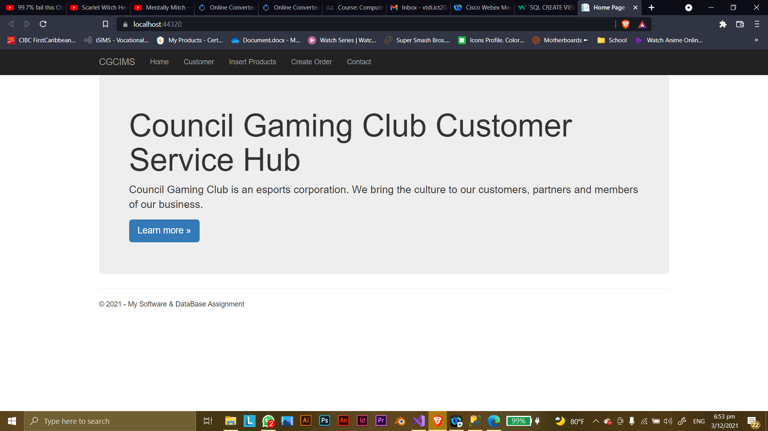

*This is the main page of the website. This Page shows the navigation bar that shows the Home, Customer, Insert Products, Create order and contact page. The Learn More also a link to the other socials for the company.*

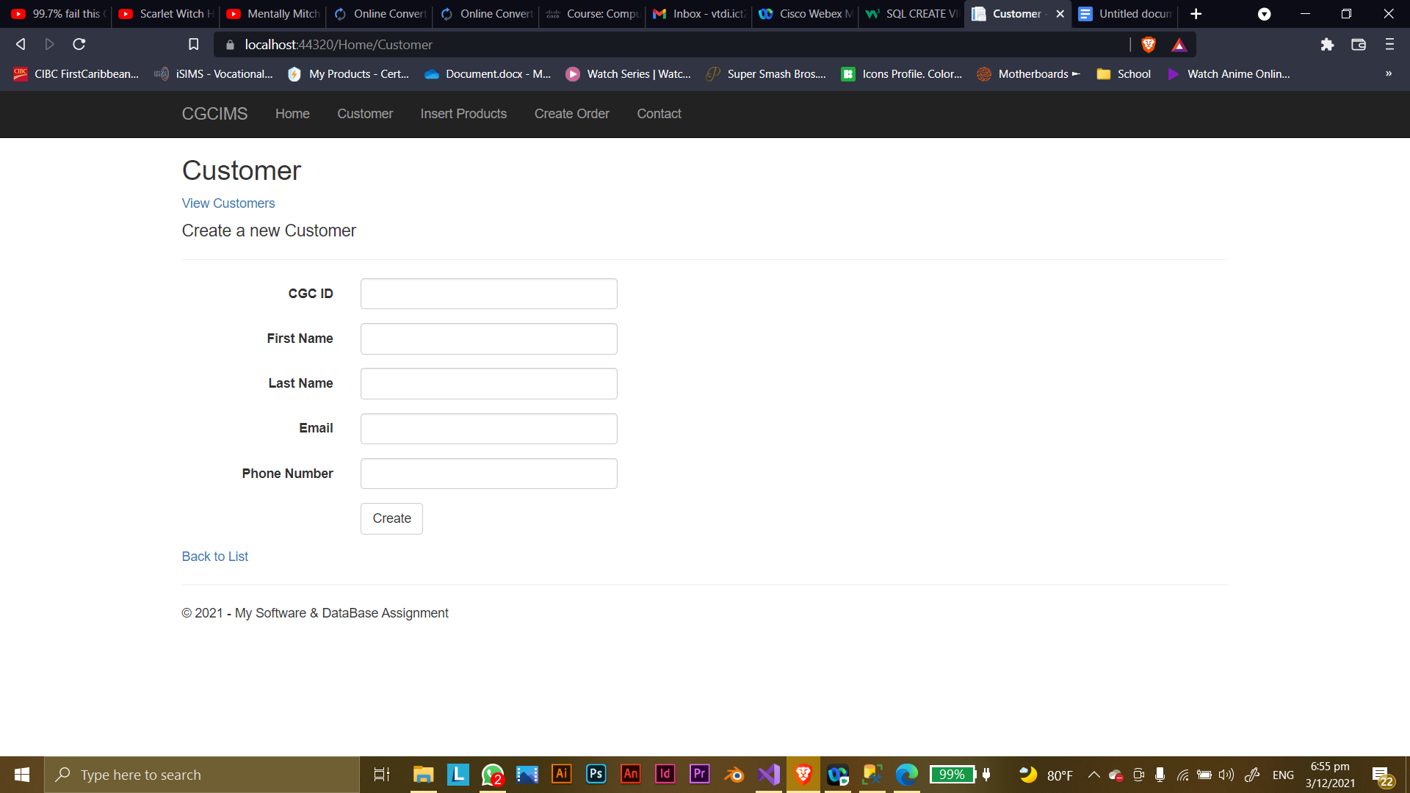

*This page is where employees are able to create a new customer by inserting their information into the required fields.*

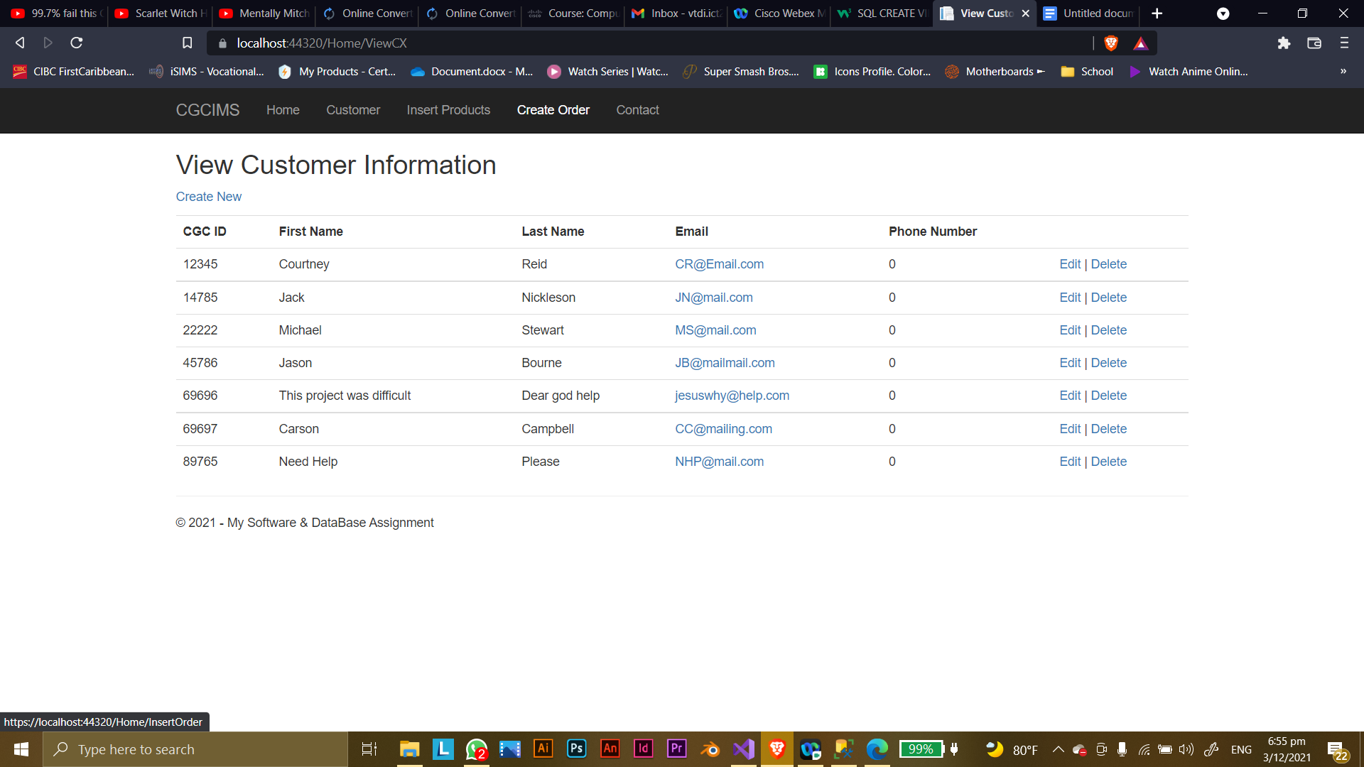

*This is the page that displays customer information.*

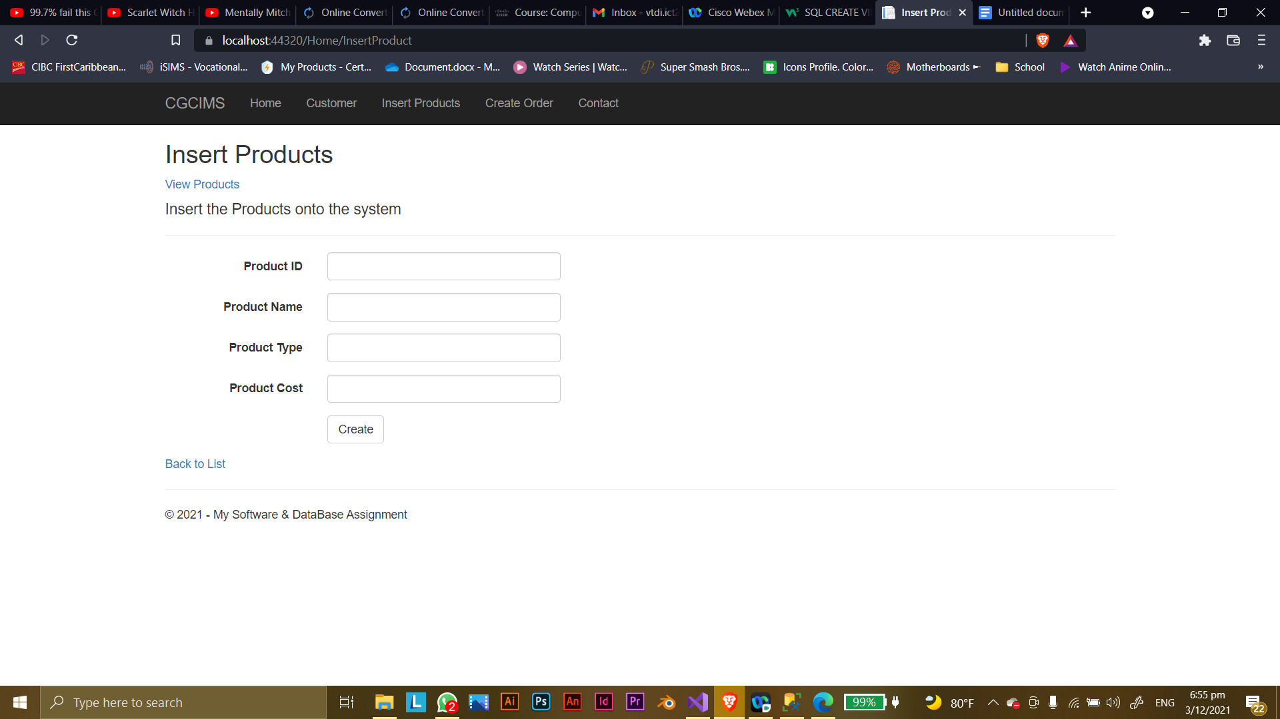

*This is the page that asks the employee to insert products.*

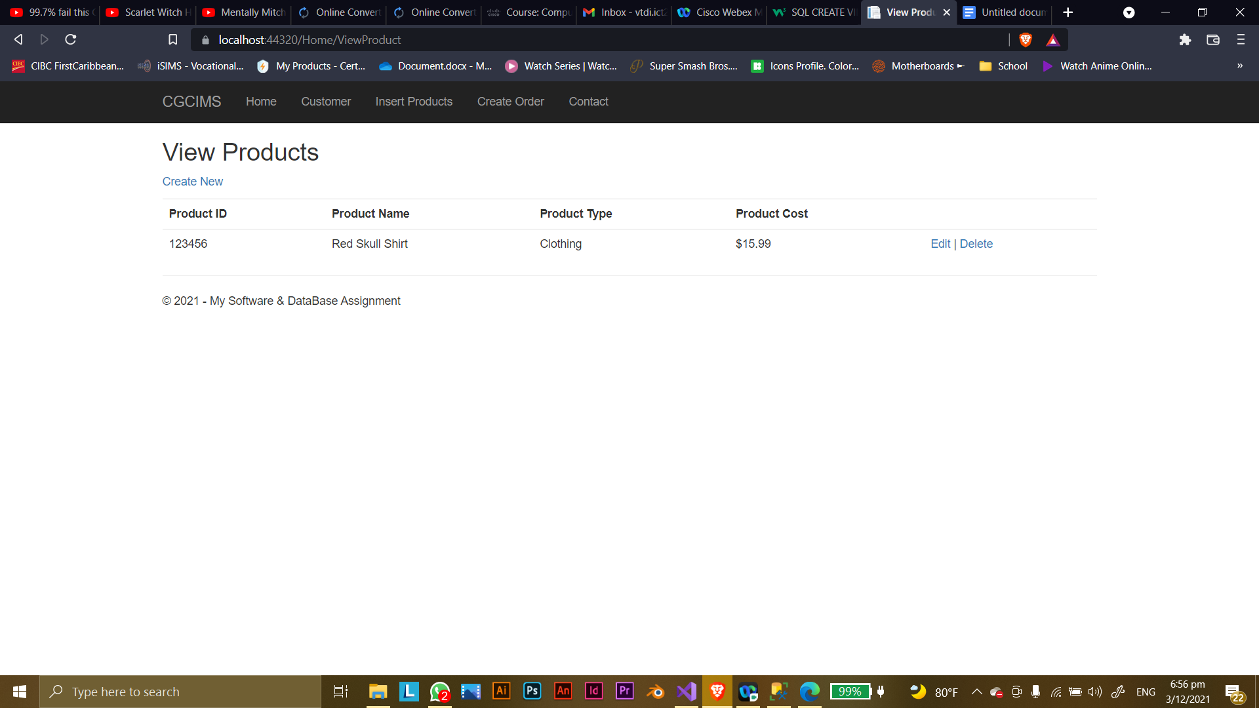

*This is the page where you are able to view the product that was entered on the previous page.*

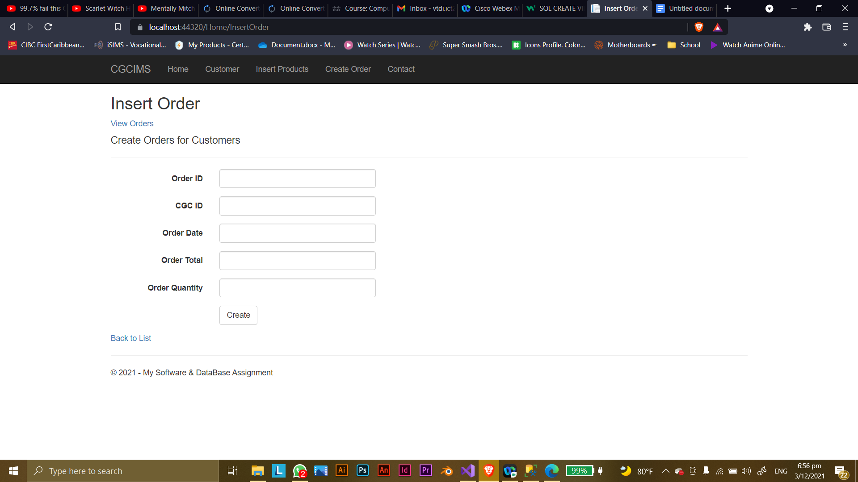

*This page is where the user inserts orders received.*

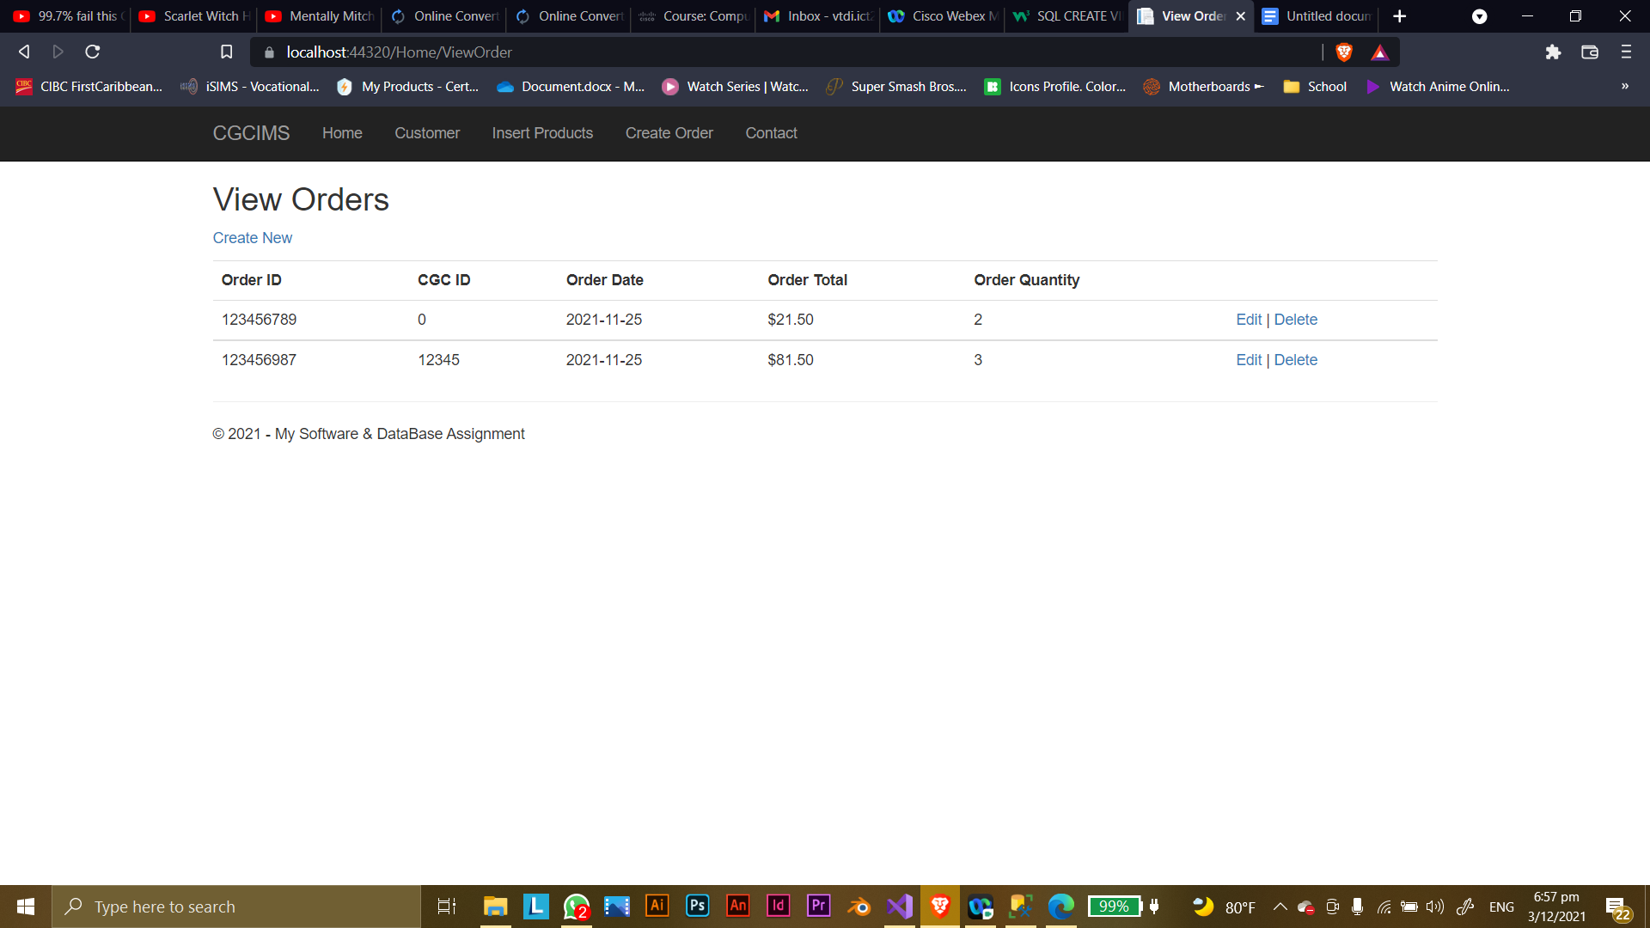

*This page displays the information created prior.*

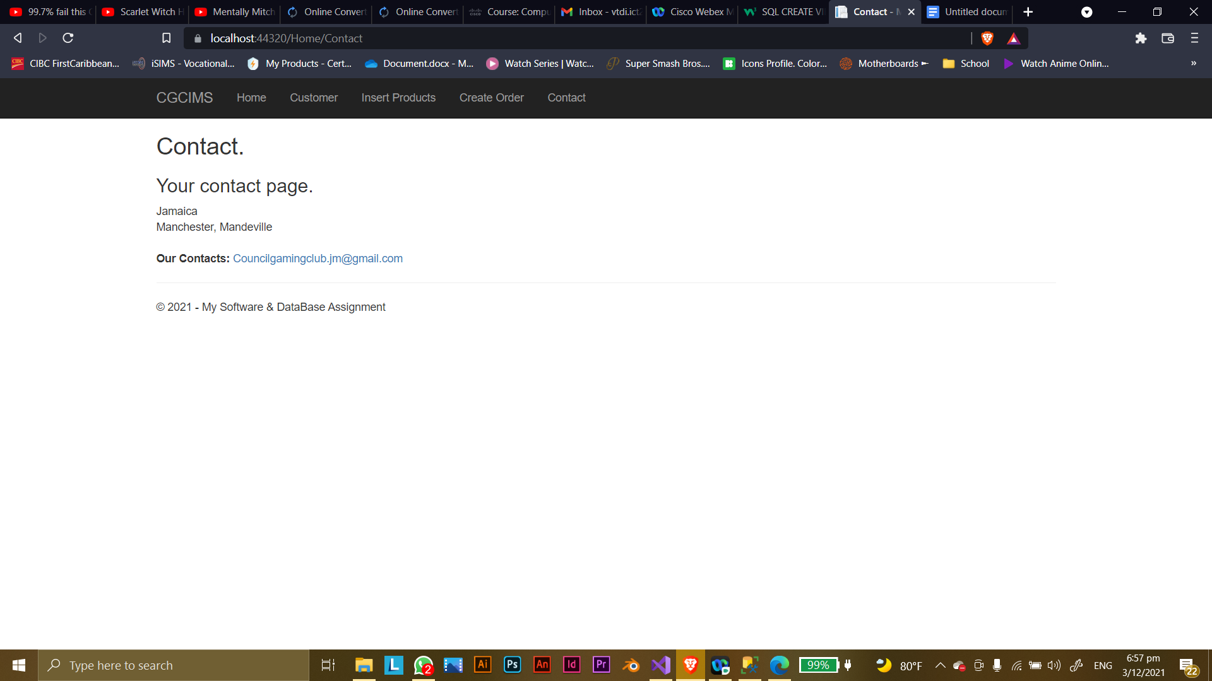

*This page on the website shows the contact page for Council Gaming Club’s Gmail*

***Data Flow Diagrams (DFDs)***

***CONTEXT DIAGRAM***

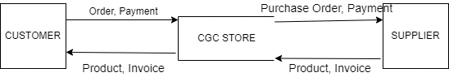

***LEVEL 0***

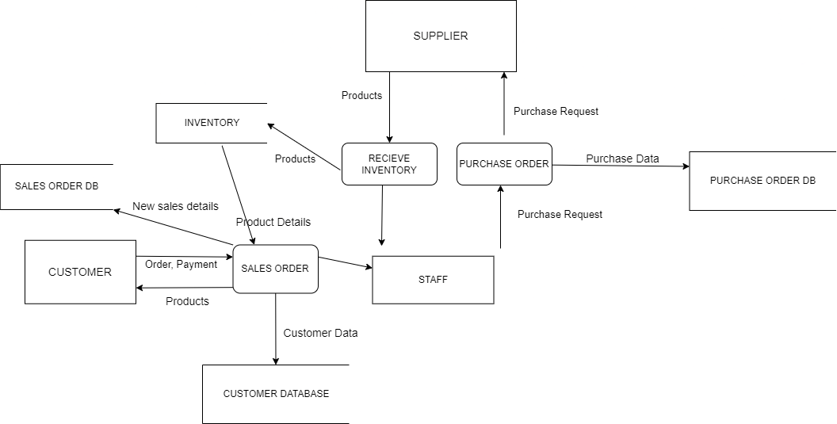

***LEVEL 1- SALES ORDER PROCESS***

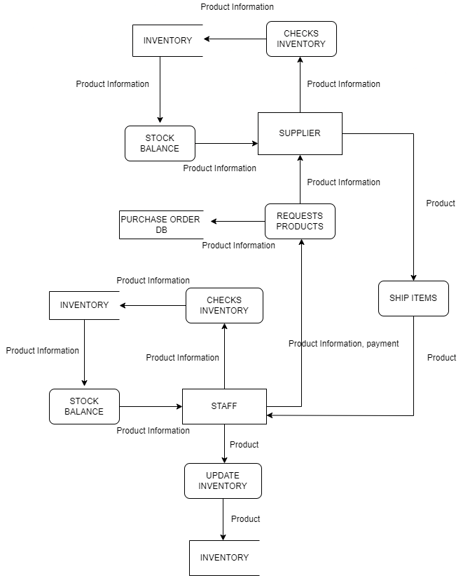

***LEVEL 1 – PURCHASE ORDER PROCESS***

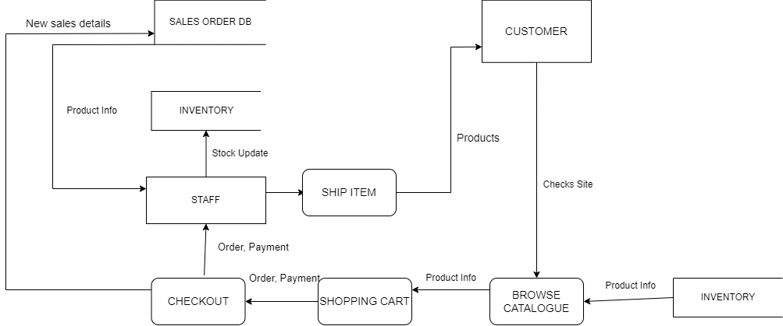

***USE CASE DIAGRAM***

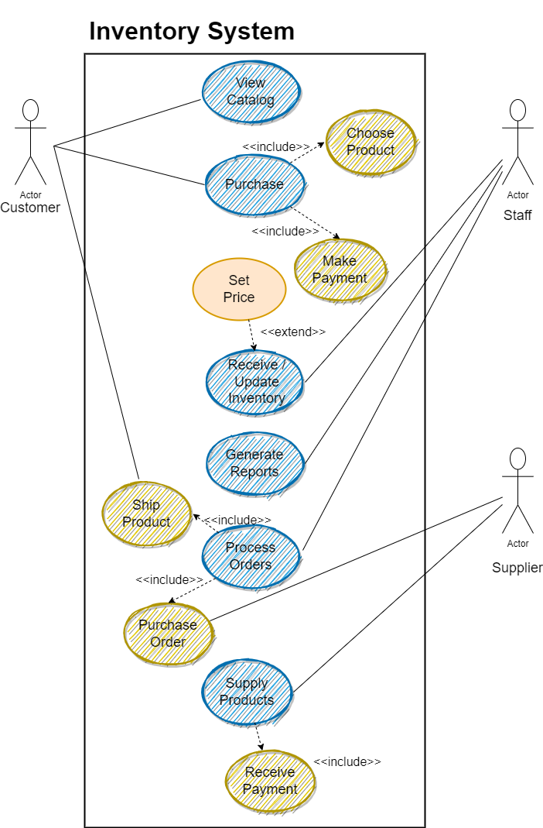

***CLASS DIAGRAM***

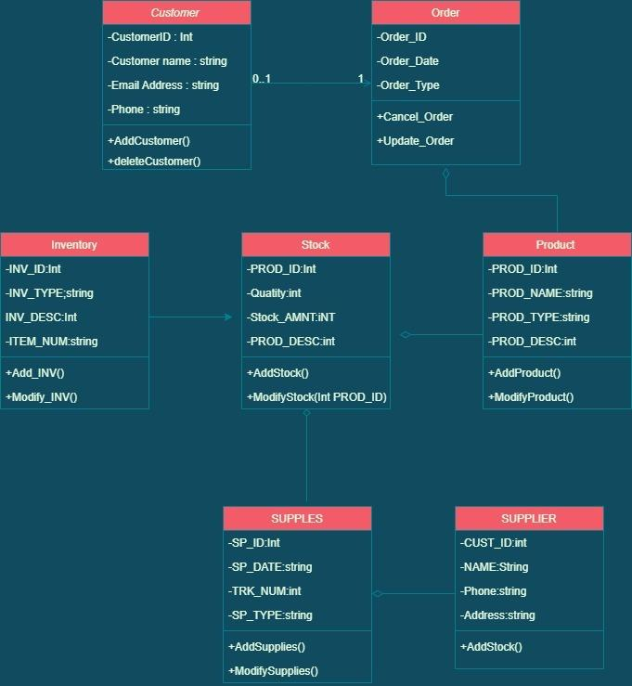

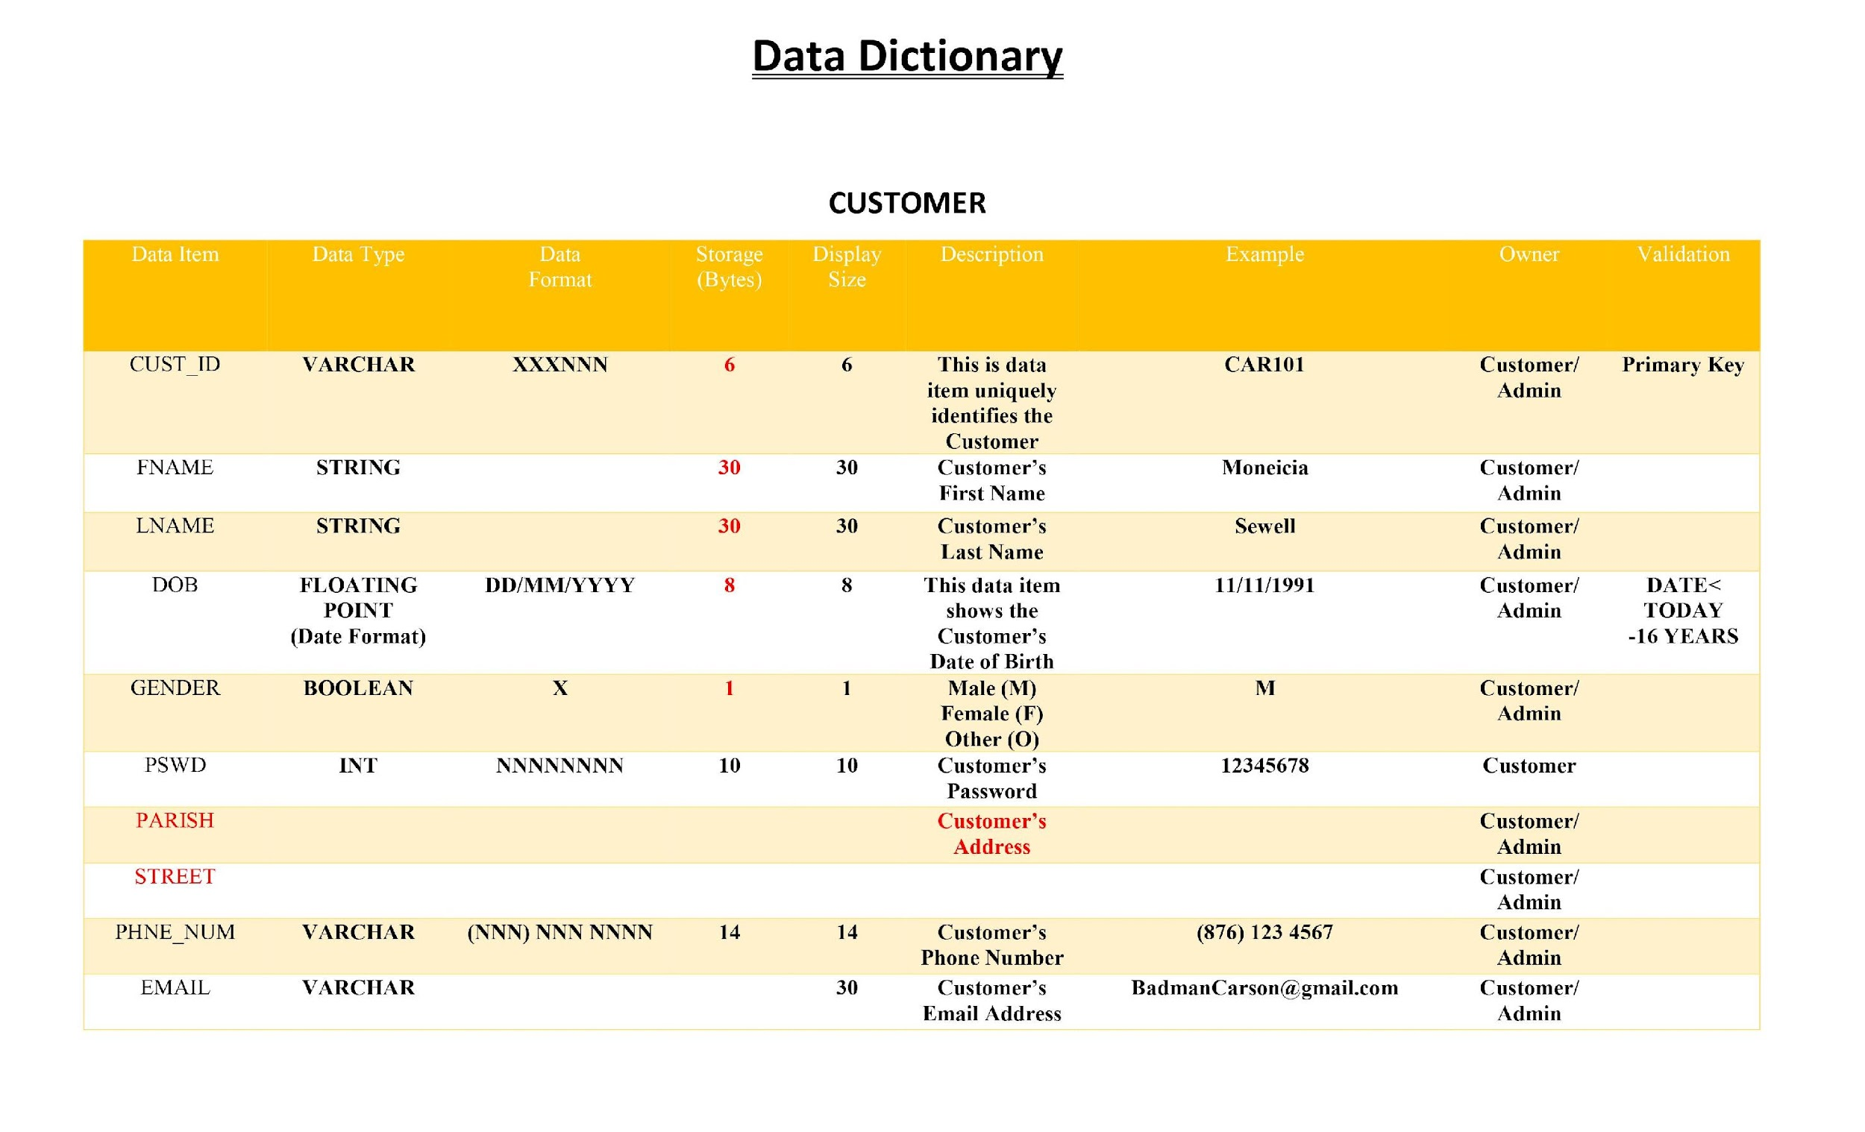

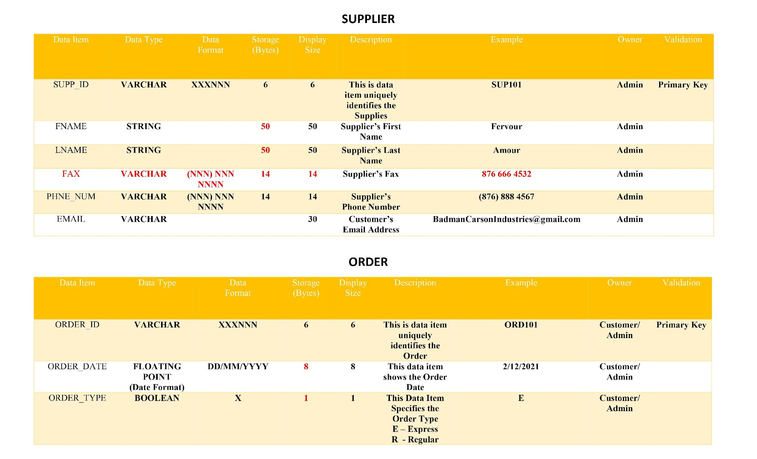

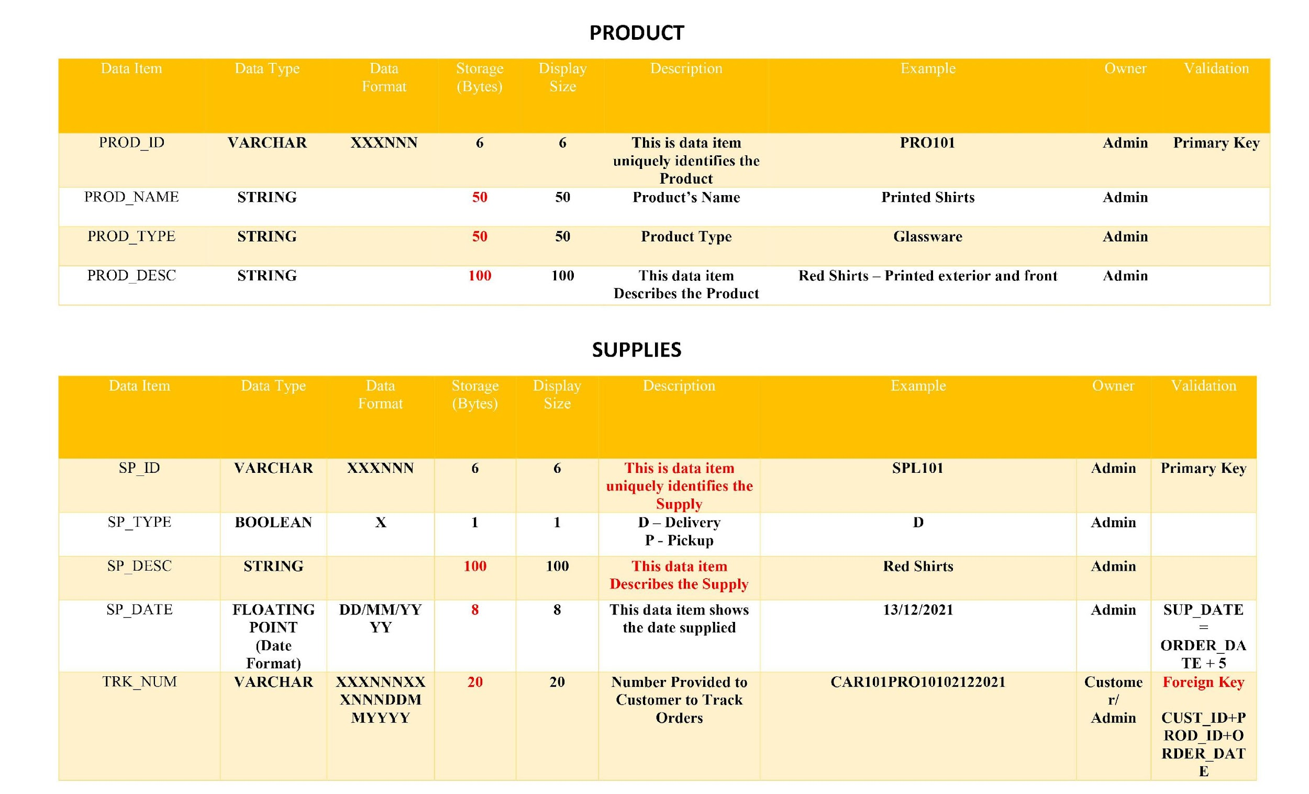

ERD

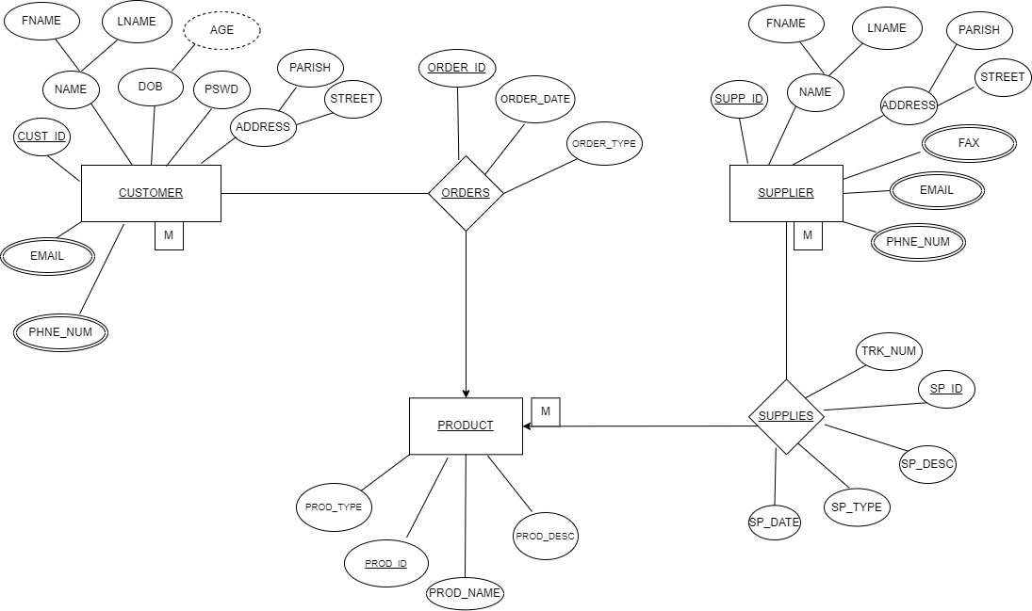

Activity Diagram

